**A**

1)MS Word is –

A) spreadsheet processor

B) graphic editor

C) word processor

D) database management system

E) operating system

2) which ribbon tab contains the group of zoom commands

A) On the View tab

B) On the Review tab

C) On the İnsert tab

D) On the Home tab

E) On the Page Layout tab

3) To create a new document based on templates in Word 2010:

A) Home🡪New

B) Insert🡪New

C) File🡪New

D) Page Layout🡪New

E) Mailings🡪New

4) What commands are executed to write the selected fragment in bold letters in MS word 2010

A) Home🡪Font🡪Bold

B) Insert🡪Text Box

C) Page Layout🡪Orientation

D) Home🡪Paragraph

E) View🡪Draft

5) Which ribbon tab is the group of commands shown in the picture

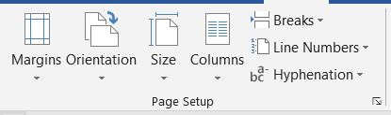

A)Page Layout

B) Insert

C) Home

D) View

E) Review

6) One of the given ribbon groups is not included in the home tab

A) Paragraph

B) Clipboard

C) Font

D) Styles

E) Themes

7) The Home ribbon tab does not include which of the following?

A) Bold

B) Font Color

C) Object

D) Text Effects

E) Copy

8) one of the following is not included in the File ribbon tab

A) Save

B) Open

C) Paste

D) New

E) Print

9) What class of software does MS word program belong to?

A) System

B) algorithmic languages

C) application

D) standart

E) operating system

10) The commands of the File,Home, Insert,Formulas,View section of the MS Word text editor

11) Mathematical expressions in Matlab system